MINI PROJECT DOCUMENTATION

This project focuses on cleaning an employee dataset in Microsoft Excel and developing an interactive dashboard in Power BI."

Submitted By
Name: RESHMA JOY

Table of Contents
- Introduction
- Objectives
- Dataset Description
- Data Pre-processing in Excel
- Power BI Dashboard
- Key Insights
- Conclusion
- Reference

Introduction
Data analysis is essential for organisations to make informed business decisions. However, raw datasets often contain missing values, duplicate records, inconsistent formats, and invalid data, making analysis difficult. This project focuses on cleaning an employee dataset using Microsoft Excel and creating an interactive dashboard in Power BIThe cleaned dataset enables meaningful analysis and better business insights."

Project Objectives
The objectives of this project are:
- Clean a raw employee dataset.
- Remove duplicate records.
- Handle missing values.
- Standardise data formats.
- Prepare the dataset for analysis.
- Build an interactive dashboard in Power BI.
- Generate useful business insights from employee data

Dataset Description
Dataset Name: Messy Employee Dataset
Source: https://www.kaggle.com/datasets/desolution01/messy-employee-dataset

Dataset Features
The dataset contains employee information such as:
- Employee ID
- Employee Name
- Age
- Gender
- Department
- Region
- Salary
- Joining Date
- Status
The dataset intentionally contains:
- Missing values
- Duplicate records
- Incorrect formats
- Blank cells
- Invalid entries
These issues make it suitable for practising data cleaning.
Tools Used
Tool | Purpose
Microsoft Excel | -Data Cleaning and Transformation
Power BI Desktop | -Dashboard Creation
Kaggle | -Dataset Source

Data Pre-processing in Excel
The following preprocessing steps were performed.

Step 1: Remove Duplicate Records
Used
Data → Remove Duplicates
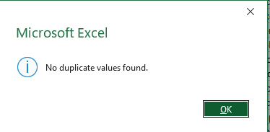
Duplicate employee records were removed.
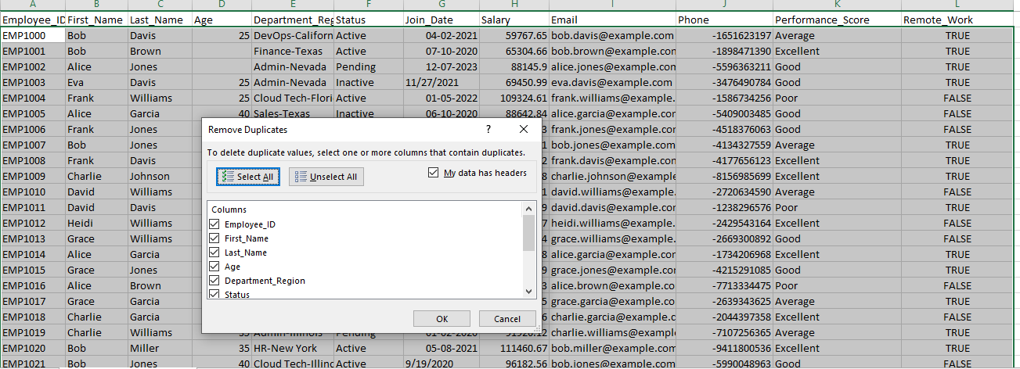

Step 2: Handle Missing Values

Identifying Missing Values
The dataset was examined to identify missing values. In Microsoft Excel, the Go to Special → Blanks feature was used to locate blank cells, and Conditional Formatting was applied to highlight missing values for easier identification.
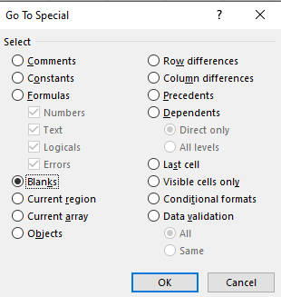
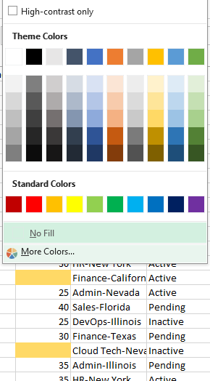

Missing Age values were replaced using the Median. The median was used because it is less affected by extreme salary values (outliers) and provides a reliable estimate for replacing missing numerical values.
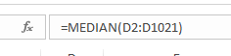
Missing values in the Age column were replaced with the median value of 30.
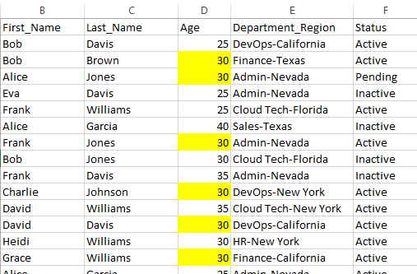

Step 3: Standardization of Formats
Date Format Standardization ✅
The Join Date column contained dates in two different formats (DD-MM-YYYY and MM/DD/YYYY). To maintain consistency throughout the dataset, the date values were standardized into a single DD-MM-YYYY format using Microsoft Excel
- Date Format Standardization
- • Applied a Filter to the Join Date column.
- • Filtered the records containing dates in the MM/DD/YYYY format.
- • Highlighted and selected the filtered date cells.
- • Navigated to Data → Text to Columns.
- • Selected Date as the Column Data Format and chose MDY (Month-Day-Year).
- • Clicked Finish to convert the selected dates.
- • Applied the DD-MM-YYYY format using Format Cells to maintain a consistent date format throughout the dataset.
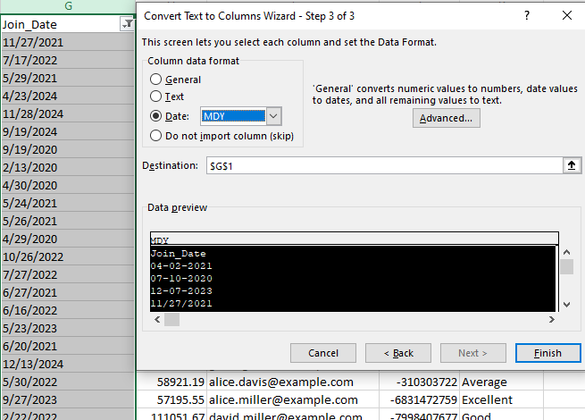
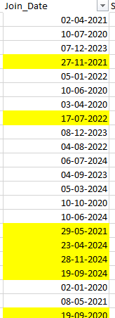

Name Standardization✅

The employee names were standardized by merging the First Name and Last-named columns into a single Employee Name column. This improved data consistency and made the Power BI dashboard easier to read and analyses
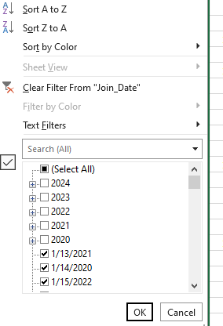

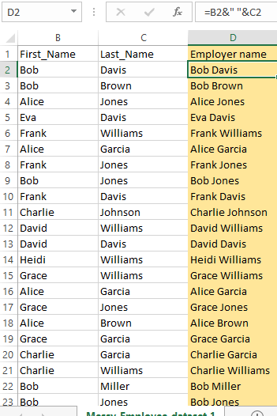

Salary Format Standardization✅

The Salary column was formatted using a currency format ($) to clearly identify salary values and maintain consistency throughout the dataset
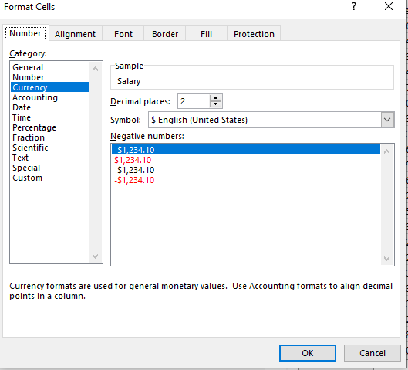
Phone Number Standardization✅
- The phone number column contained country codes with a minus (-) symbol instead of a plus (+) symbol.
- The incorrect symbol was replaced to standardize the phone number format.
- Example:
  - Before: -64XXXXXXXX
  - After: +64XXXXXXXX
- The phone number column was kept as Text format to preserve the country code and special characters.
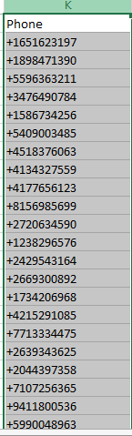

Department and Region Separation✅
- The Department Region column contained two different attributes combined in a single column.
- The column was split into two separate columns: Department and Region.
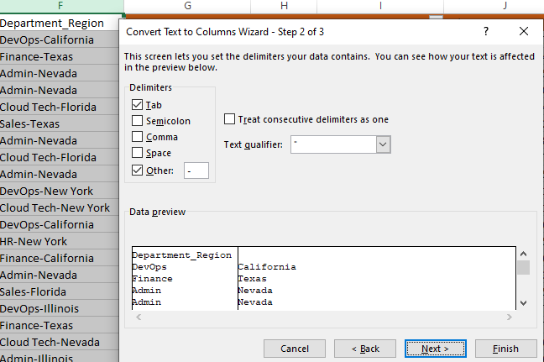
- The hyphen (-) delimiter was used to separate the values.

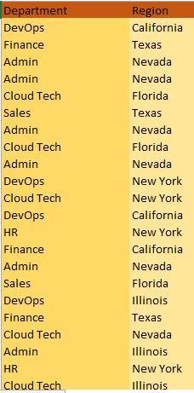

Handling Missing Values in Salary Column✅
During the data cleaning process, missing values were identified in the Salary column. Since salary data can contain extreme values (high-income employees), replacing missing values using the mean could affect the accuracy because outliers can increase the average value.
Therefore, the Median imputation method was selected to replace the missing salary values. The median represents the middle value of the salary distribution and is less affected by extreme salary values.
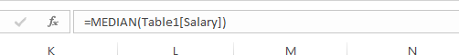

Creating Calculated Fields✅

Salary Scale
Objective:
A calculated column named Salary Scale was created to classify employees into different salary categories. This helps in analysing the workforce based on salary ranges and simplifies reporting and visualization.
Formula Used:
=IF (J2<70000,"Low”, IF(J2<100000,"Medium","High"))

Outcome:
Each employee is automatically assigned a salary category (Low, Medium, or High), making it easier to compare employees and create summary reports and Power BI visualizations.

Years of Experience✅
Objective:
A calculated column named Years of Experience was created to calculate the total work experience of each employee from the joining date to the current date (2026).
Formula Used:
=DATEDIF (I2, TODAY(),"Y")
Logic:
The DATEDIF function calculates the number of complete years between the employee's joining date and the current date.
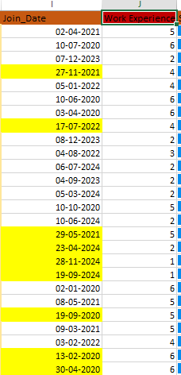

Outcome:
The column displays each employee's total years of experience, which can be used for employee analysis, experience-based grouping, and dashboard reporting.

Age Group Classification✅
The Age Group column was created by categorizing employees based on their age. Instead of analysing individual age values, employees were grouped into meaningful ranges (20–29, 30–39, 40–49, and 50+). This transformation simplifies demographic analysis and improves the readability of reports and dashboards.
Creating age groups enables effective comparison of employee distribution across different age categories and supports better visualization in Power BI. It is particularly useful for bar charts, column charts, and pie charts, where grouped categories provide clearer insights than individual age values.
\

Experience Group Classification✅
The Experience Group column was created by categorizing employees based on their years of work experience. Instead of analysing each experience value individually, employees were grouped into meaningful ranges (0–2 Years, 3–5 Years, 6–10 Years, and 10+ Years). This transformation simplifies workforce analysis and improves the readability of reports.
The grouped experience categories support effective visualization in Power BI by enabling comparisons of employee distribution, average salary, and performance across different experience levels. This categorization provides clearer insights than using individual experience values.

Performance Rating Score
The Performance Rating Score column was created by converting qualitative performance ratings into numerical values. The ratings Poor, Average, Good, and Excellent were assigned scores of 1, 2, 3, and 4, respectively.
This transformation enables quantitative analysis of employee performance, making it possible to calculate average performance scores and compare performance across departments, regions, experience groups, and salary categories. It also supports more effective data visualization and statistical analysis in Power BI.

Final Cleaned Dataset

Objective
A separate worksheet named "Cleaned Data" was created to prepare the dataset for Power BI analysis. The worksheet contains only the required and transformed columns, making the data easier to analyse and visualize.

Process
The cleaned dataset was prepared after completing all data cleaning and transformation activities in Microsoft Excel. Unnecessary columns were removed, while the important original columns and newly created calculated fields were retained. The dataset was then organised in a structured table format with consistent headers and standardized values.

Included Columns
The final cleaned dataset contains the following columns:
- Employee ID
- Employee Name
- Age
- Age Group
- Department
- Region
- Join Date
- Join Year
- Salary
- Salary Scale
- Performance Score
- Performance Rating Score
- Remote Work
- Years of Experience
- Experience Group

Outcome
The final cleaned dataset is accurate, consistent, and ready for analysis in Power BI. The transformed columns improve data aggregation, filtering, and visualization, enabling the creation of interactive dashboards and meaningful business insights.

Visualization 1:

KPI Cards
KPI Cards are used to show important information in the dashboard. I created four KPI Cards to give a quick summary of the employee data.
- Total Employees – Shows the total number of employees.
- Average Salary – Shows the average salary of all employees.
- Average Age – Shows the average age of employees.
- Total Departments – Shows the total number of departments.

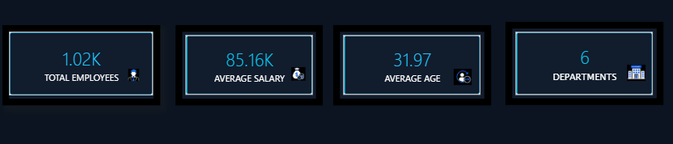
These KPI Cards help users understand the employee data quickly without checking the entire dataset. They are placed at the top of the dashboard for easy viewing.The values change automatically when filters or slicers are applied.

Visualization 2:

Salary by Department – Analysis
Purpose:
To compare the total salary expenditure across different departments.
A Clustered Column Chart was created using Department as the Axis and Sum of Salary as the Value.
Findings:
- DevOps has the highest total salary expenditure.
- Sales is the second-highest department.
- Cloud Tech has the lowest salary expenditure.
- HR, Finance, and Admin have similar salary expenses.
Recommendation:
The company should review salary allocation and ensure that departments with higher salary costs are delivering better performance.

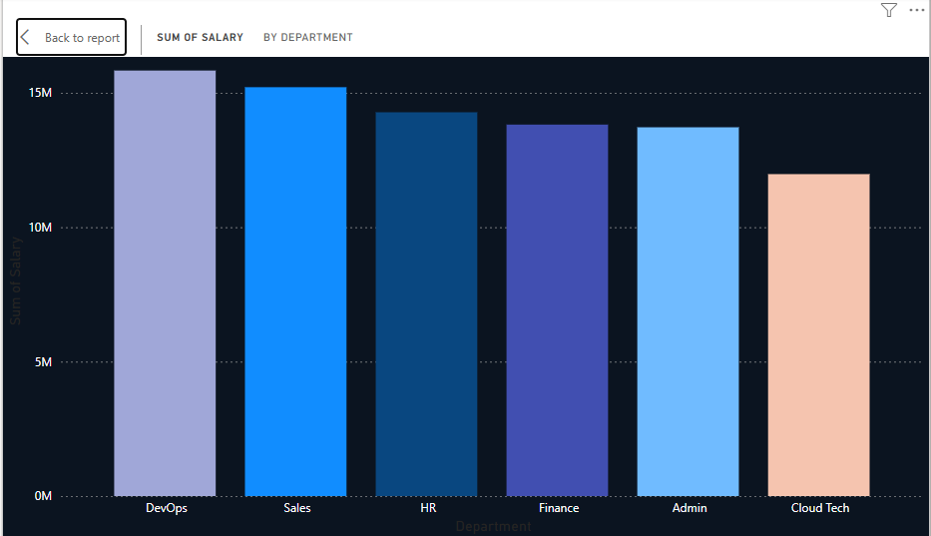

Visualization 3

Employee Count by Department and Performance Rating
Chart: Stacked Column Chart
X-Axis: Department. Y-Axis: Count of Employee ID
Legend: Performance Rating Scale (1, 2, 3, 4)
Purpose:
To analyse the number of employees in each department based on their performance ratings.
Analysis:
- DevOps has the highest number of employees across all performance rating levels.
- Sales, HR, Finance, and Admin have a balanced distribution of performance ratings.
- Cloud Tech has the lowest employee count.
- Overall, employees with different performance ratings are distributed across all departments.
Recommendation:
The company can use this analysis to identify high-performing departments, provide additional support where needed, and improve overall employee performance
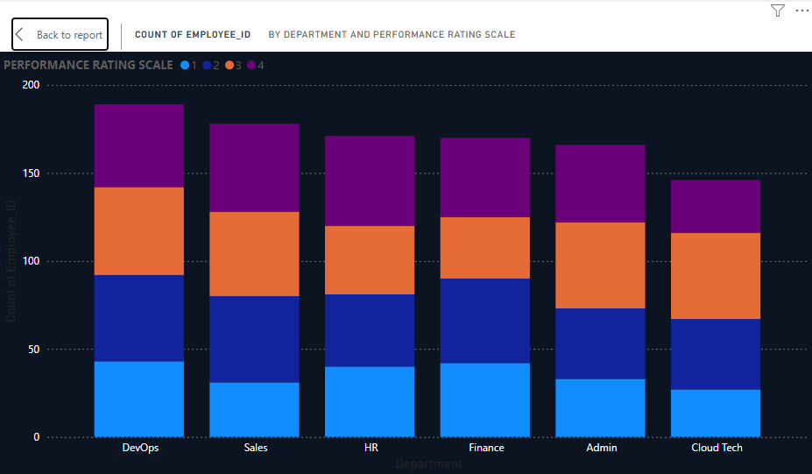
Visualization 4
Employee Count by Department
Chart: Bar Chart
X-Axis: Count of Employee ID
Y-Axis: Department
Purpose:
To compare the number of employees in each department and identify departments with the highest and lowest workforce.
Analysis:
- DevOps has the highest number of employees.
- Sales has the second-highest employee count.
- HR, Finance, and Admin have a similar number of employees.
- Cloud Tech has the lowest employee count.
Recommendation:
The company can use this analysis for workforce planning, resource allocation, and recruitment decisions. Departments with fewer employees can be reviewed to ensure they have sufficient staffing based on business requirements.
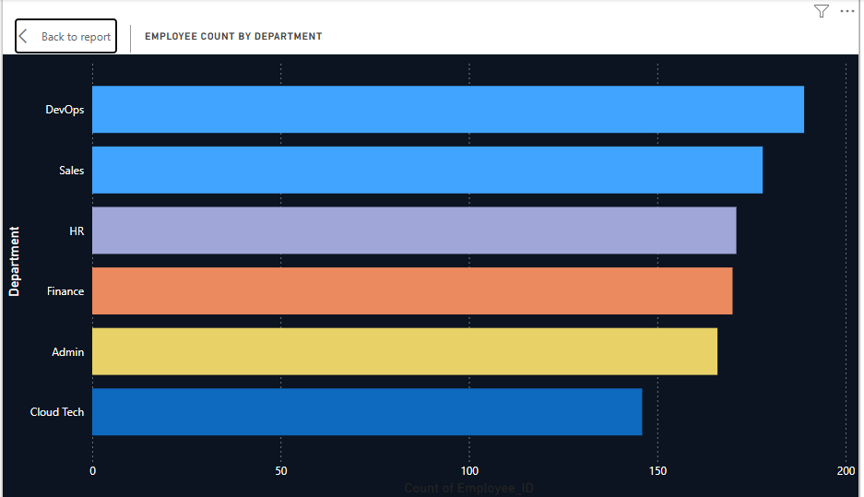

Visualization 5
Remote Work Distribution
Chart: Donut Chart
Category: Remote Work (True / False)
Values: Count of Region
Purpose:
To analyse the distribution of employees working remotely and those working from the office.
Analysis:
- 50.29% of employees are working remotely.
- 49.71% of employees are working from the office.
- The workforce is almost equally divided between remote and on-site work.
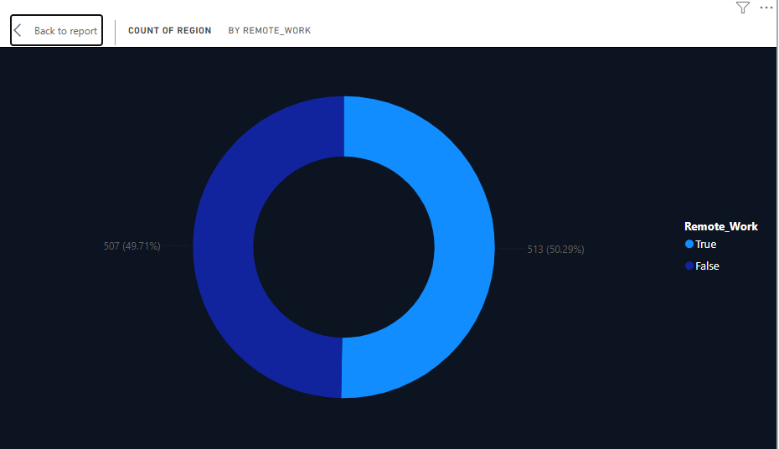
Recommendation:
The company should continue maintaining a balanced hybrid work model and regularly monitor remote work trends to ensure employee productivity and effective collaboration

Visualization 6
Average Work Experience by Department
Chart: Line Chart
X-Axis: Department
Y-Axis: Average Work Experience
Purpose:
To compare the average work experience of employees across different departments.
Analysis:
- Admin has the highest average work experience.
- Sales and Cloud Tech have similar average experience levels.
- Finance has a moderate level of work experience.
- DevOps and HR have the lowest average work experience.
Recommendation:
The company can use this analysis to identify departments with less experienced employees and provide training, mentoring, or recruitment strategies to strengthen workforce experience.

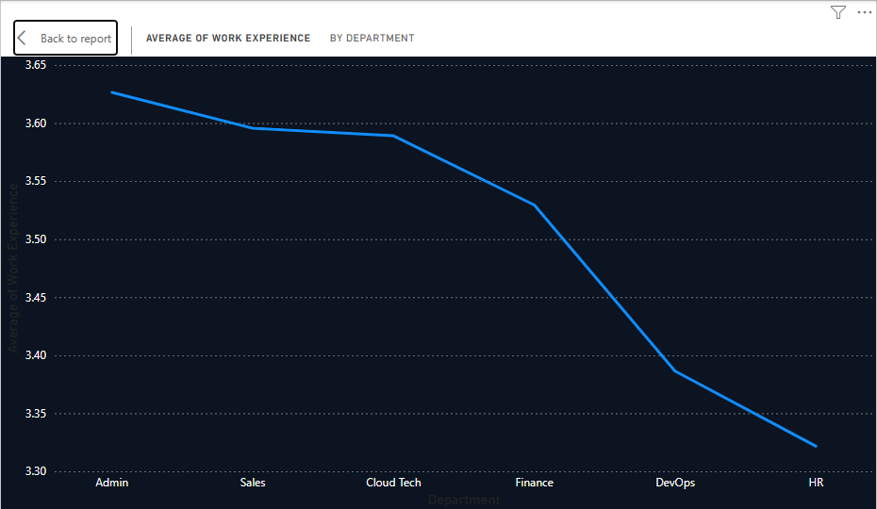
Visualization 7
Employee Count by Region
Chart: Donut Chart
Category: Region
Values: Count of Employee ID
Purpose:
To analyse the distribution of employees across different regions.
Analysis:
- California has the highest number of employees.
- Florida is the second-highest region by employee count.
- Nevada, Illinois, and New York have a similar number of employees.
- Texas has the lowest employee count among the regions.
Recommendation:
The company can use this analysis to monitor workforce distribution across regions and make informed decisions on recruitment, resource allocation, and regional workforce planning.
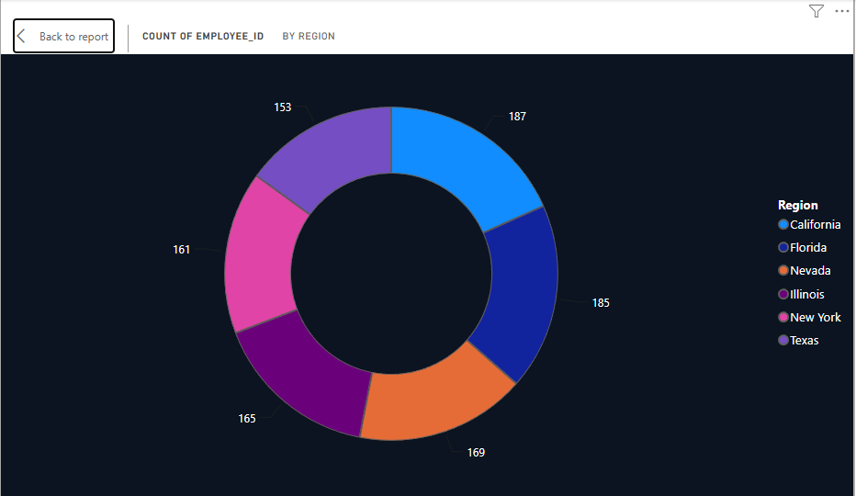

Conclusion
This project successfully transformed a raw employee dataset into a clean and structured dataset using Microsoft Excel. An interactive Power BI dashboard was developed to analyze employee distribution, salary allocation, performance ratings, work experience, remote work trends, and regional distribution. The insights generated from the dashboard can support better workforce planning, performance evaluation, and business decision-making

Future Recommendations
Based on the insights from the dashboard, the company can take the following actions to improve overall performance:
- Provide additional training and mentoring to departments with lower performance levels.
- Review salary allocation in departments with higher salary expenditure.
- Recruit additional employees in departments with lower workforce strength when required.
- Monitor remote work practices regularly to maintain productivity and effective collaboration.
- Strengthen recruitment and training strategies in departments with lower average work experience.
- Improve regional workforce planning by allocating resources according to employee distribution.
These recommendations can help the company improve employee performance, workforce management, and overall business efficiency.

